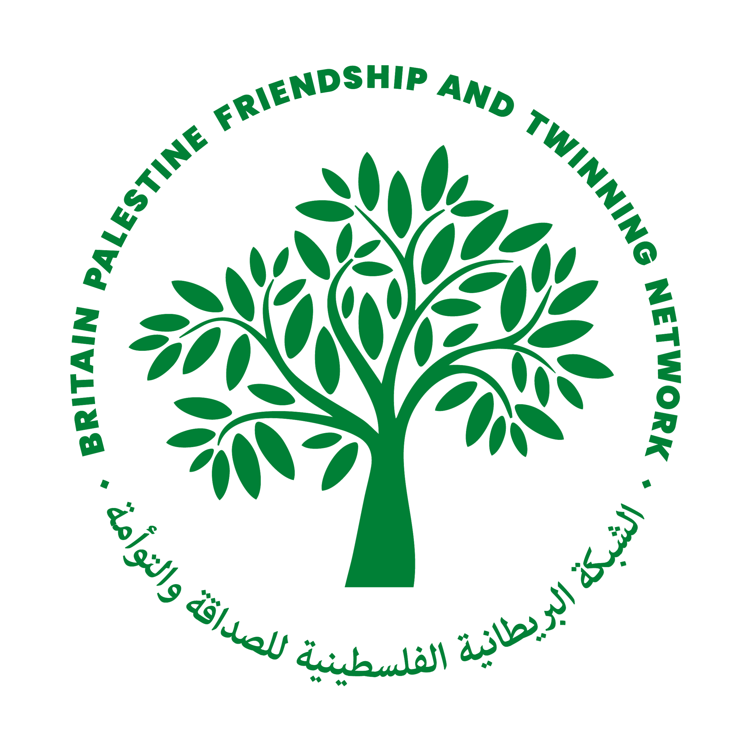
SEEKING A FRIENDSHIP OR TWINNING LINK
Britain Palestine Friendship and Twinning Network

How to use this document:
- this document is designed to be used by groups in Palestine and in the UK
- it can be completed by any community, group or place that is hoping to find a friendship or twinning link with somewhere in Britain or somewhere in Palestine
- ideally, both places / groups would complete the document so you can measure your own group’s starting point and read about potential twinning partners
- fill this out and send it to palestinetwinning@yahoo.com and if you already have one, your contact in Britain or Palestine

Name of place or organisation hoping to build a friendship or twinning link:
(this could be the name of a community, town, city, school, organisation, interest group, church etc.)

Date:

Please also send any photos or videos you have to share about your community / group

Please describe your group or community (including explaining where it is in Palestine / Britain)
Name(s) of person(s) completing this form, and role or position within group or community, and their contact details:
Why do you want to build friendships or a twinning link – mention any specific ideas or aims
How big is your organisation / community?

Who else is supporting this ambition to build friendship links in your community / organisation?

How will you get your whole community involved (if it is a place-based link)?

Do you have any English / Arabic speakers and writers?

Do you have an internet connection so we can communicate in between visits (if West Bank- for Gaza all contact will be online?
How do you plan to ensure you can stay in touch with your friendship / twinning partner?

Any other thoughts or ideas you have:
MAKE FRIENDS
BUILD SOLIDARITY
INSPIRE HOPE

